UNCOVERING THE GAMING INDUSTRY’S

HIDDEN GEMS:

A COMPREHENSIVE ANALYSIS OF VIDEO GAMES SALES



INTRODUCTION

Video games are electronic gadgets that involve user interaction or input device in the form of keyboard, joystick, motion sensor device etc. Through the past decade many videogames have been published through various platforms such as PS2, PS3, WII etc. These games published would belong to different age group (ex: E, E10+, M, RP etc.) published by different publication all over the world.

Through this dataset we can get to see an interactive dashboard which shows sales of videogames, top games played and different comparisons for the past 40 years through various charts such as pie chart, bar graph, heat map etc.

The dataset used in the visualization contains a list of video games with sales greater than 100,000 copies. It was generated by a scrape of vgchartz.com.

Video gaming industry is huge and the spending on video games per year is huge too. Sales of different types of games vary widely between countries due to local preferences. According to the market research firm SuperData, as of May 2015, the global games market was worth USD 74.2 billion. By region, North America accounted for 23.6 billion dollars, Asia for 23.1 billion dollars, Europe for 22.1 billion dollars and South America for 4.5 billion dollars. There are different genres, publisher and platforms for video games. This project relates to the sales of these video games based on different regions and analyses the sales. Also I have analysed which genre, platform or publisher is the most popular and has maximum number of sales.

PROBLEM DEFINITION AND DESIGN THINKING

EMPATHY MAP

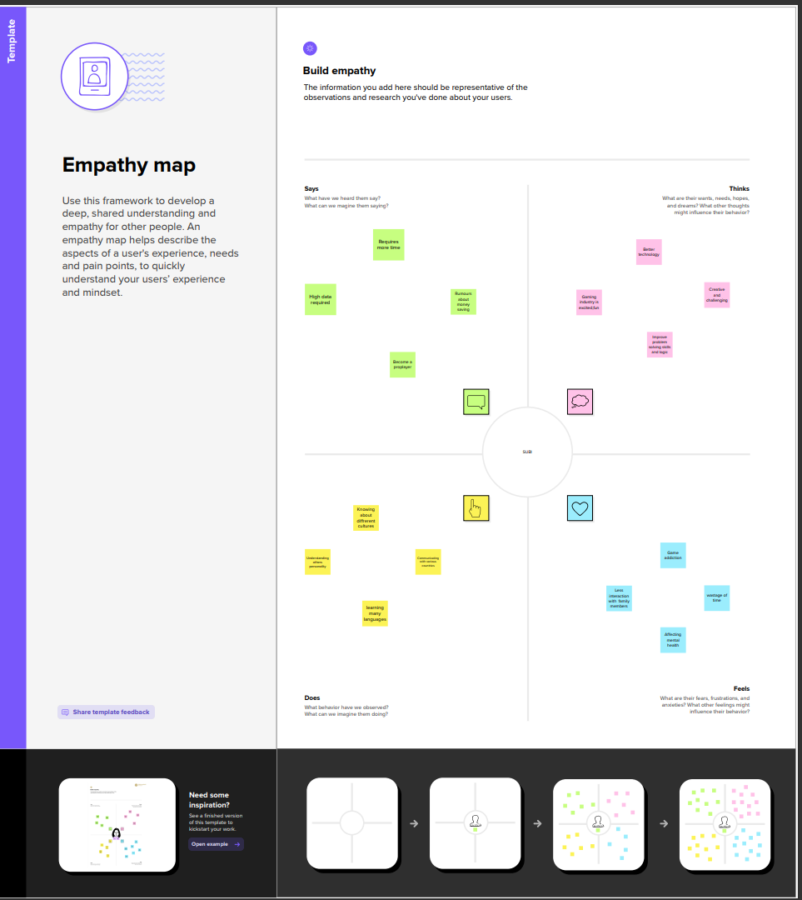

IDEATION AND BRAINSTORMING MAP

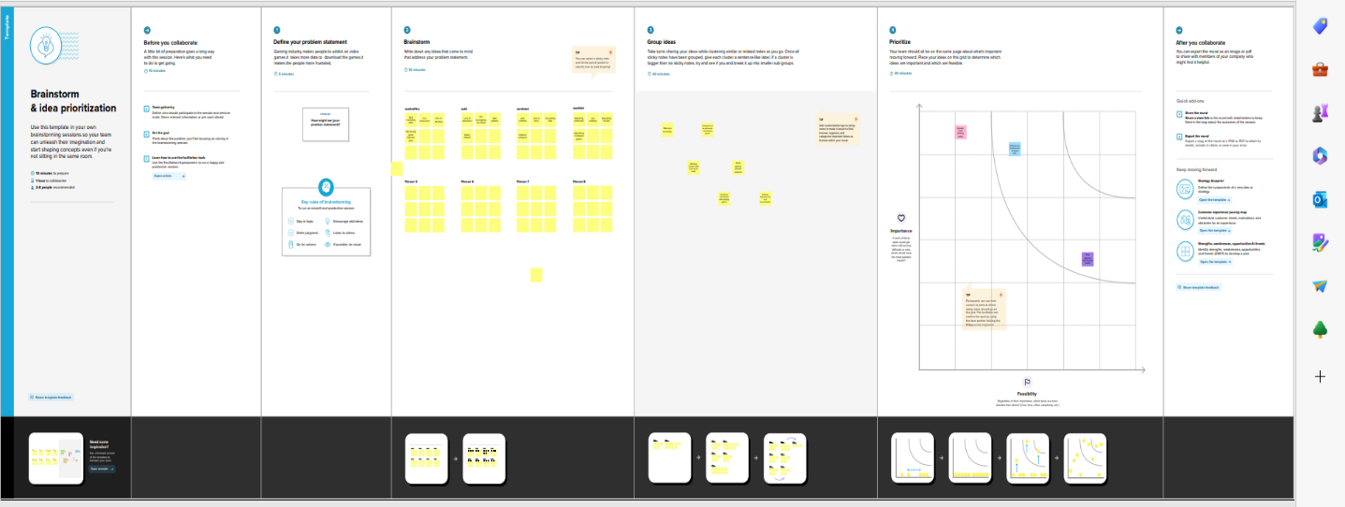

RESULT

DASHBOARD

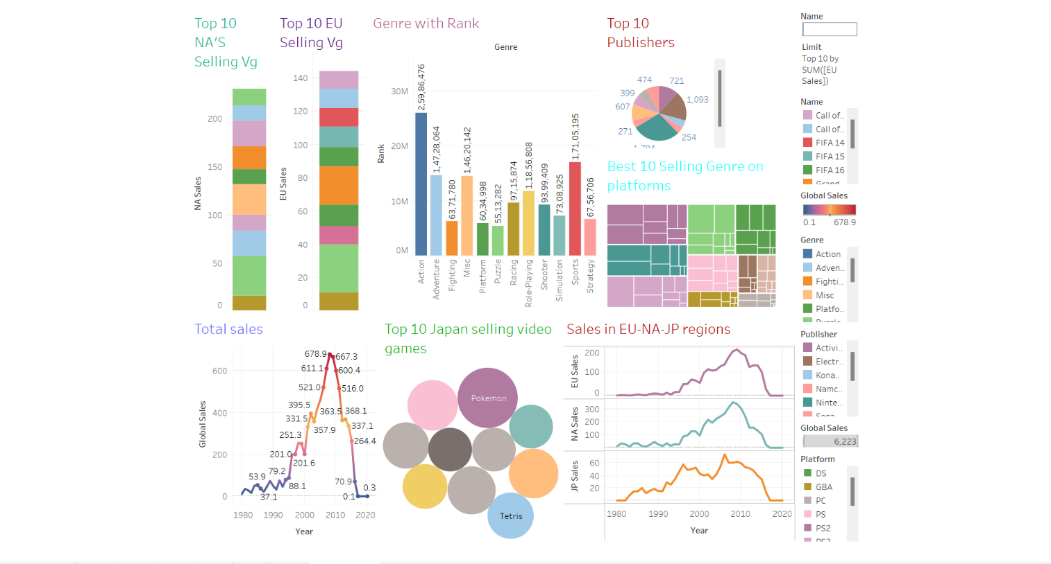

STORY

Story 1

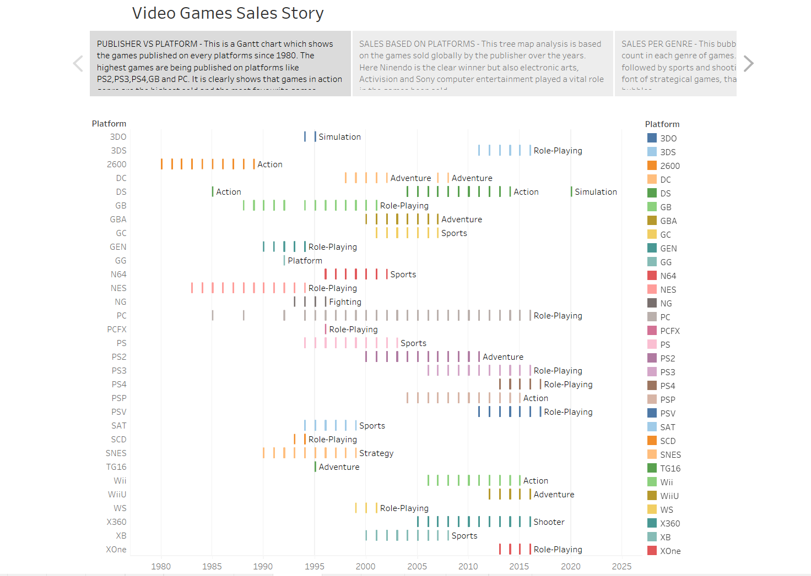

Story 2

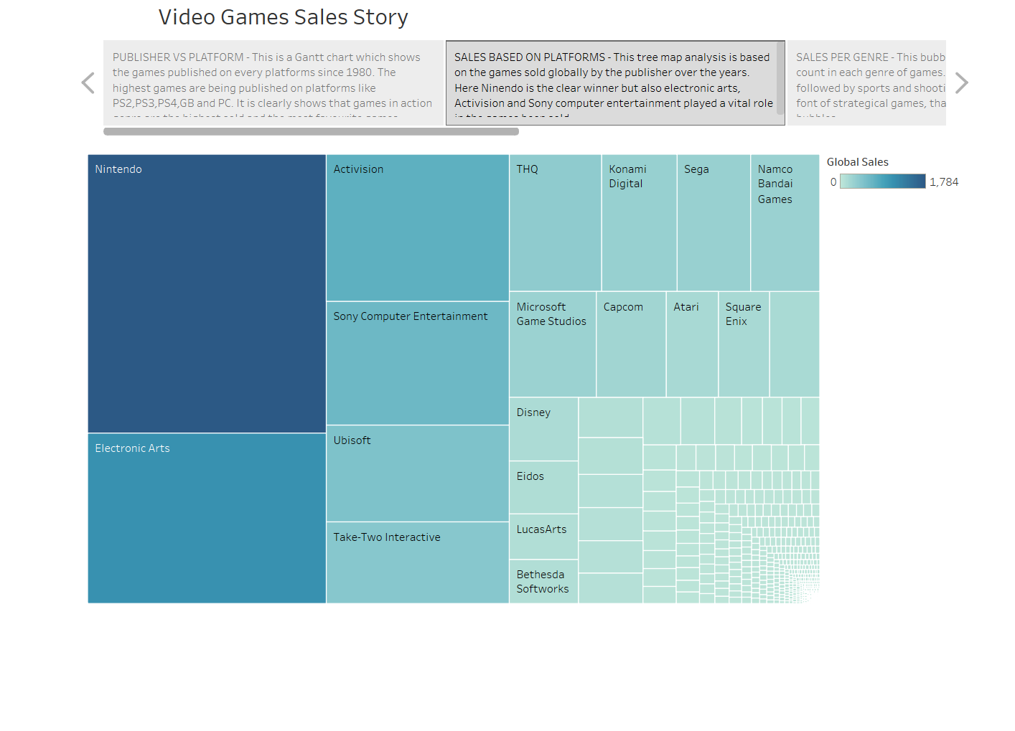

Story 3

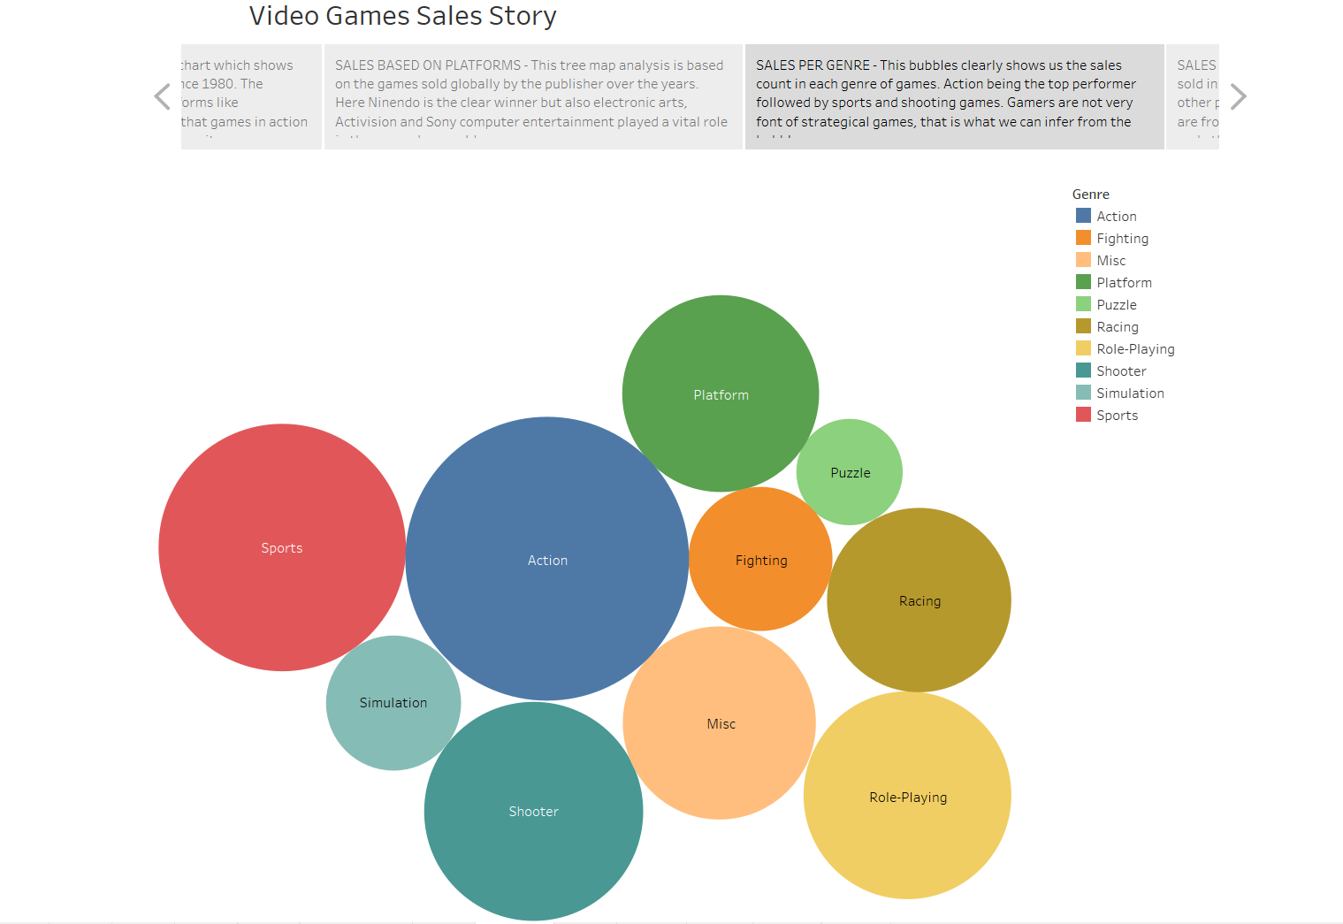

Story 4

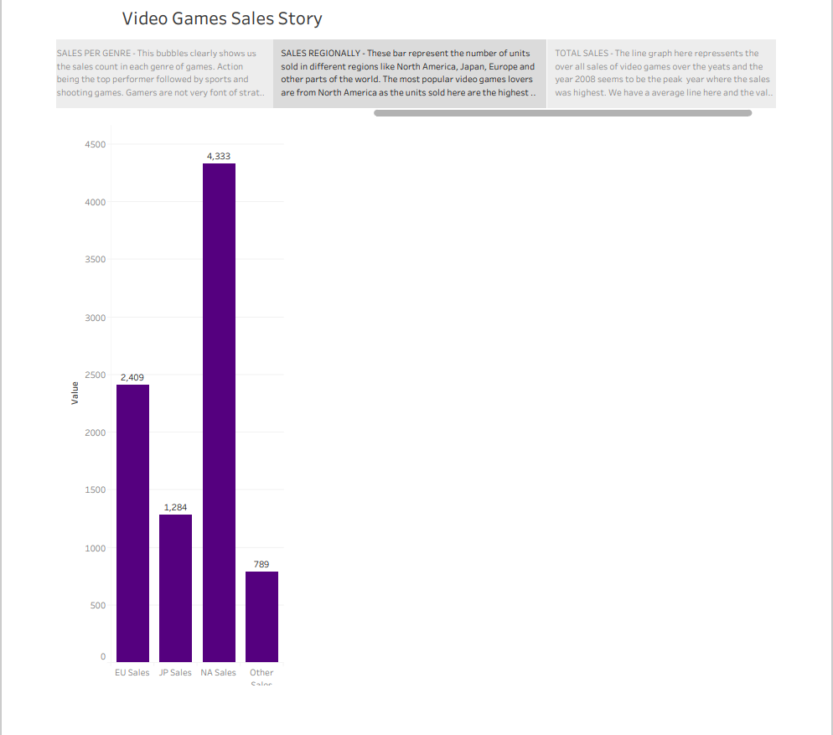

Story 5

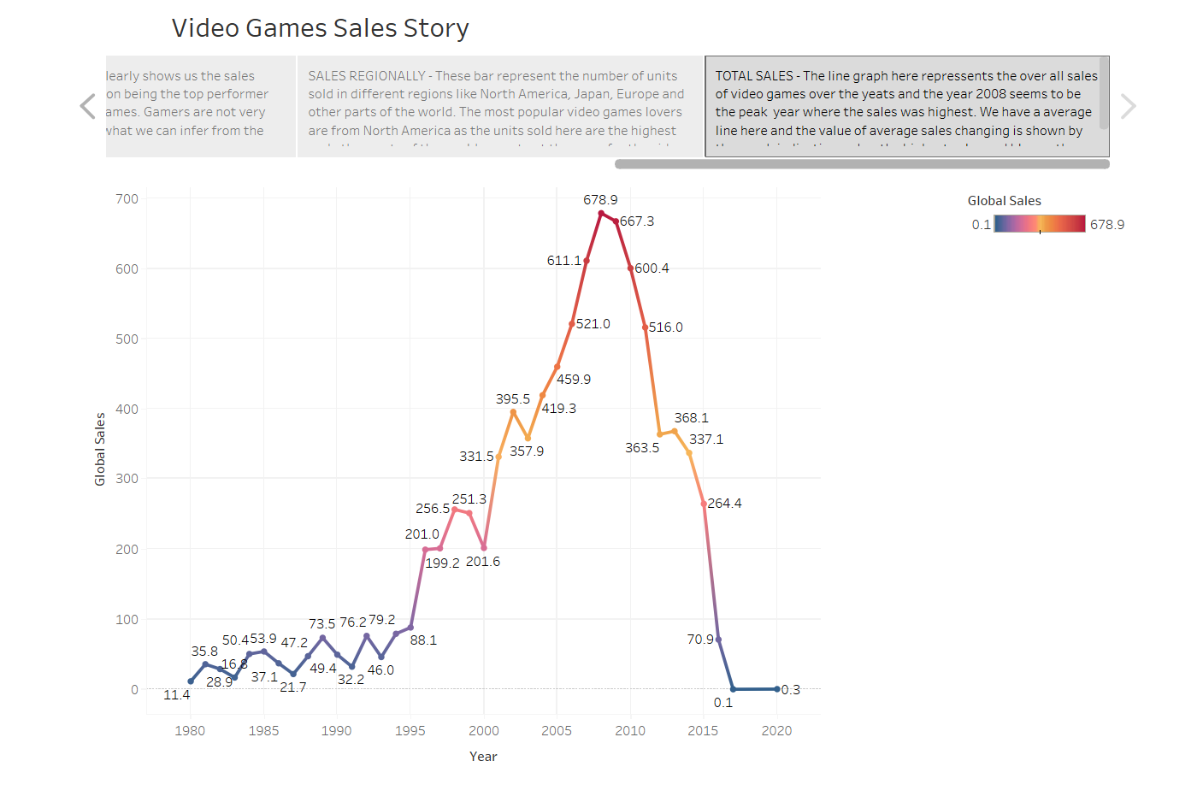

ADVANTAGES OF VIDEO GAMES ANALYSIS

Video games sales analysis is the process of collecting and analyzing data about the sales of video games in order to understand market trends and consumer behavior. This type of analysis can be useful for a variety of purposes, including identifying the most popular games and genres, predicting future sales, and developing marketing strategies.

Using this video games sales analysis, we can easily understand about the video games sales in various category. This analysis also explains the information about the number of units sold, retail price and platforms on which the games are played. It helps us to understand the needs and preferences of consumers and to identify opportunities for growth and innovation.

There are some other advantages, i.e,

* They speed up response time.
* They encourage teamwork.
* They stimulate creativity, focus and visual memory.
* They improve strategy and leadership.
* They teach languages.
* Critical thinking.

APPLICATION OF VIDEO GAMES ANALYSIS

Game development applications and tools can help

game developers and creators make realistic games with advanced features. Both beginner and advanced game developers use these tools to enhance the quality and performance of their games. Knowing about some popular game development tools can help you make better games and increase the quality of your work output. In this article, we discuss the utility and advantages of game development software tools, list six popular tools and share some tips on selecting a suitable application as per you requirements.

Game development software applications are tools that help game developers make video games. They typically simplify processes such as converting assets, designing, level editing, compilation, simulation, testing and debugging. It is important to note that game development tools and applications typically get designed for one game and re-used for other games by the same developer or company. These tools usually have no value for regular game players, and outside of the development team, they have very few applications.

Game development tools help game designers and developers create concepts, characters and environments. Usually, some coding is required to convert these elements into a consistent video game. These tools are helpful for beginner and expert game developers as they can help expedite processes by automating the code for common game features. Using such tools, game developers can create gameplay physics, characters, menus, effects, buttons and links.

FUTURE SCOPE

The future of the video game industry looks dazzling. Consumer demand is growing, technology is advancing quickly, and new monetization models are taking off. Bain’s analysis forecasts that global revenue for games could grow by more than 50% over the next five years.

Three big trends are changing the video game industry: better technology, metaverse-style environments, and new monetization models.

As competition increases, scale will become even more important, since big games are expensive to make and require a massive global audience to succeed. Good franchise management and fan engagement also will become more critical than ever, prompting leading companies to put it at the centre of decisions. Success will require finding and keeping the best creative and technical talent-a challenge in an industry that’s losing developers to larger tech companies.

CONCLUSION

This paper focusses on descriptive analysis, data analysis of related contents and data visualization of the video game dataset to derive the corresponding business application strategies for different groups in the market. The results show that platforms can prioritize the purchase of games in the ‘Action’ genre and need to focus more on game distribution quality than quantity; publishers should choose platforms and game genres with high sales to sell and invent; users should focus on platforms with high sales and experience to choose a certain type of game product. This study can stimulate game marketing and economy and bring the market into a virtuous cycle. The video game market will have broader sales prospects and is worth promoting and propagating vigorously.